Tomato Leaf Disease Identification by Restructured Deep Residual Dense Network

ABSTRACT

As COVID-19 spread worldwide; many major grain-producing countries have adopted measures to restrict their grain exports; food security has aroused great concern from various parties. How to improve grain production has become one of the most important issues facing all countries. However, crop diseases are a difficult problem for many farmers so it is important to master the severity of crop diseases timely and accurately to help staff take further intervention measures to minimize plants being further infected. A restructured residual dense network was proposed for tomato leaf disease identification; this hybrid deep learning model combines the advantages of deep residual networks and dense networks, which can reduce the number of training process parameters to improve calculation accuracy as well as enhance the flow of information and gradients. The original RDN model was first used in image super resolution, so we need to restructure the network architecture for classification tasks through adjusted input image features and hyper parameters. The restructured residual dense network model can obtain significant improvements over most of the state-of-the-art models in crop leaf identification, as well as requiring less computation to achieve high performance.

CHAPTER 1

INTRODUCTION

Food security has been increasingly addressed; many countries and institutions are working to increase food production. How to master crop diseases and insect pests more accurately and effectively is an important research area. Specifically, leaf diseases greatly influence crop growth and yield. Researchers have performed considerable work to effectively identify the severities of crop diseases.

To present, the research on crop disease identification is mainly divided into two topics. One is the traditional computer vision method, which is mainly based on spectral detection and feature extraction to identify different diseases. Different types of diseases cause different leaf features, which leads to different shapes and colors of leaves eroded by diseases and healthy crops. The other topic uses machine learning technology to identify leaf images. That is, the identification of disease images is extracted by using supervised or unsupervised learning algorithms and the recognition is carried out through the different features of diseased and healthy plants.

With the development of machine learning and the technology of Internet of things (IOT) in agriculture, which automatically identifies plant diseases and insect pests, especially for the application of deep learning, the accuracy and efficiency of crop leaf disease identification have further improved. We used a deep learning method to extract the disease features on tomato leaves, such as spot blight, late blight and yellow leaf curl disease. The proposed method predicted the category of each disease after continuous iterative learning, and the accuracy showed in the training set and test set increased by 0.6% and 2.3%. We introduced an image collection, image preprocessing, segmentation and classification method based on artificial intelligence for the task of automatic plant leaf disease detection and classification, which can easily and quickly detect and classify crop diseases in agriculture.

We proposed a leaf disease recognition method based on the AlexNet architecture. A maize leaf feature enhancement framework was designed first which enhanced the maize features under the complex environment and then designed an AlexNet architecture network named DMS-Robust AlexNet, which improved the capability of feature extraction combined with dilated convolution and multiscale convolution. We proposed a generative adversarial network-based leaf disease identification model.

This model generated images of four different leaf diseases for training, then fused DenseNet and instance normalization to identify real and fake disease images as well as feature extraction capability on grape leaf lesions. Finally, the method stabilized the training process by applying a deep regret gradient penalty. The results showed that the GAN-based data augmentation method can effectively overcome the overfitting problem in disease identification, and this method can also effectively improve identification accuracy.

We proposed a multiple classifier integration method for image recognition, which was divided into 3 parts. First, a public dataset of diseased and healthy plant leaves was adopted, and then CNN was used to classify different plant diseases which were evaluated separately. Finally, it was evaluated for accurately diagnosing plant dis- eases by the integrated three models. Experimental results showed that on a split test set the top-1 accuracy approached 99.92%.

We proposed an end-to-end plant disease diagnostic model-based deep neural network, which can reliably classify plant types and plant diseases. This model consists of two components: the leaf segmentation part that separates the leaves in the original image from the background, and the plant disease classifier, which is based on a two-head network that classifies plant diseases with the features extracted by various popular pretrained models. Experimental results demonstrate that this method can achieve a 0.9807 plant classification accuracy and a 0.8745 disease recognition accuracy.

It can be seen from the above state-of-the-art methods that the research in crop leaf disease identification is mainly concentrated in computer vision and machine learning, particularly the recent development of deep learning used in agriculture. However, methods are rarely applied to crop leaf disease identification that can balance accuracy and efficiency. In this project, we propose a restructured dense residual network that adjusts the structure and parameters. The purpose of this model is to improve the performance in crop leaf identification and reduce the impact of the disease on the crop as much as possible.

CHAPTER 2

LITERATURE SURVEY

2.1 SURVEY 1
TITLE: ImageNet Classification with Deep Convolutional Neural Networks

AUTHORS: Alex Krizhevsky, Ilya Sutskever, Geoffrey E. Hinton

YEAR: 2012

DESCRIPTION:

They trained a large, deep convolutional neural network to classify the 1.2 million high- resolution images in the ImageNet LSVRC-2010 contest into the 1000 different classes. On the test data, they have achieved top-1 and top-5 error rates of 37.5% and 17.0% which is considerably better than the previous state-of-the-art. The neural network, which has 60 million parameters and 650,000 neurons, consists of five convolutional layers, some of which are followed by max-pooling layers, and three fully-connected layers with a final 1000-way softmax. To make training faster, they have used non-saturating neurons and a very efficient GPU implementation of the convolution operation. To reduce overfitting in the fully-connected layers they have employed a recently-developed regularization method called “dropout” that proved to be very effective. They have also entered a variant of this model in the ILSVRC- 2012 competition and achieved a winning top-5 test error rate of 15.3%, compared to 26.2% achieved by the second-best entry.

2.2 SURVEY 2
TITLE: Going deeper with convolutions

AUTHORS: Christian Szegedy, Wei Liu, Yangqing Jia, Pierre Sermanet, Scott Reed, Dragomir Anguelov, Dumitru Erhan, Vincent Vanhoucke, Andrew Rabinovich

YEAR: 2012

DESCRIPTION:

They propose a deep convolutional neural network architecture codenamed Inception, which was responsible for setting the new state of the art for classification and detection in the ImageNet Large-Scale Visual Recognition Challenge 2014 (ILSVRC14). The main hallmark of this architecture is the improved utilization of the computing resources inside the network. This was achieved by a carefully crafted design that allows for increasing the depth and width of the network while keeping the computational budget constant. To optimize quality, the architectural decisions were based on the Hebbian principle and the intuition of multi-scale processing. One particular incarnation used in our submission for ILSVRC14 is called GoogLeNet, a 22 layers deep network, the quality of which is assessed in the context of classification and detection.

2.3 SURVEY 3
TITLE: Deep Residual Learning for Image Recognition AUTHORS: Kaiming He, Xiangyu Zhang, Shaoqing Ren, Jian Sun YEAR: 2015

DESCRIPTION:

Deeper neural networks are more difficult to train. They have presented a residual learning framework to ease the training of networks that are substantially deeper than those used previously. They have explicitly reformulated the layers as learning residual functions with reference to the layer inputs, instead of learning unreferenced functions. They have provided comprehensive empirical evidence showing that these residual networks are easier to optimize, and can gain accuracy from considerably increased depth. On the ImageNet dataset they have evaluated residual nets with a depth of up to 152 layers—8× deeper than VGG nets but still having lower complexity. An ensemble of these residual nets achieves 3.57% error on the ImageNet test set. This result won the 1st place on the ILSVRC 2015 classification task. They have also presented analysis on CIFAR-10 with 100 and 1000 layers. The depth of representations is of central importance for many visual recognition tasks. Solely due to their extremely deep representations, they have obtained a 28% relative improvement on the COCO object detection dataset. Deep residual nets are foundations of our submissions to ILSVRC & COCO 2015 competitions1, where they also won the 1st places on the tasks of ImageNet detection, ImageNet localization, COCO detection, and COCO segmentation.

2.4 SURVEY 4

TITLE: Densely Connected Convolutional Networks

AUTHORS: Gao Huang, Zhuang Liu, Laurens van der Maaten, Kilian Q. Weinberger

YEAR: 2016

DESCRIPTION:

Recent work has shown that convolutional networks can be substantially deeper, more accurate, and efficient to train if they contain shorter connections between layers close to the input and those close to the output. In this paper, they have embraced this observation and introduce the Dense Convolutional Network (DenseNet), which connects each layer to every other layer in a feed-forward fashion. Whereas traditional convolutional networks with L layers have L connections—one between each layer and its subsequent layer—our network has L(L+1)/2 direct connections. For each layer, the feature-maps of all preceding layers are used as inputs, and its own feature-maps are used as inputs into all subsequent layers. DenseNets have several compelling advantages: they alleviate the vanishing-gradient problem, strengthen feature propagation, encourage feature reuse, and substantially reduce the number of parameters. They evaluated proposed architecture on four highly competitive object recognition benchmark tasks (CIFAR-10, CIFAR-100, SVHN, and ImageNet). DenseNets obtain significant improvements over the state-of-the-art on most of them, whilst requiring less computation to achieve high performance.

2.5 SURVEY 5
TITLE: Hierarchical dense recursive network for image super-resolution
AUTHORS: Kui Jiang, ZhongyuanWang, PengYi, Junjun Jiang
YEAR: 2020
DESCRIPTION:
Image super-resolution (SR) techniques with deep convolutional network (CNN) have achieved significant improvements compared to previous shallow-learning-based methods. Especially for dense connection-based networks, these methods have yielded unprecedented achievements but bring the higher complexity and more parameters. To this end, this paper considers both reconstruction performance and efficiency, and advocates a novel hierarchical dense connection network (HDN) for image SR. First of all, we construct a hierarchical dense residual block (HDB) to promote the feature representation while saving the memory footprint with a hierarchical matrix structure design. In this way, it can provide additional interleaved pathways for information fusion and gradient optimization but with a shallower depth compare to the previous networks. In particular, a group of convolutional layers with small size (1 × 1) are embedded in HDB, releasing the computational burden and parameters by rescaling the feature dimensions. Furthermore, HDBs are connected to each other in a sharing manner, thereby allowing the network to fuse the features in different stages. At the final, the multi-scale features from these HDBs are integrated into global fusion module (GFM) for a global fusion and representation, and then the final profile-enriched residual map is obtained by realigning and sub-pixel up sampling the fusion maps. Extensive experimental results on benchmark datasets and really degraded images show that our model outperforms the state-of-the-art methods in terms of quantitative indicators and realistic visual effects, as well as enjoys a fast and accurate reconstruction.

2.6 SURVEY 6
TITLE: GRDN: Grouped Residual Dense Network for Real Image Denoising and GAN-Based Real-World Noise Modeling
AUTHORS: Dong-Wook Kim, Jae Ryun Chung, Seung-Won Jung
YEAR: 2019
DESCRIPTION:
Recent research on image denoising has progressed with the development of deep learning architectures, especially convolutional neural networks. However, real-world image denoising is still very challenging because it is not possible to obtain ideal pairs of ground-truth images and real-world noisy images. Owing to the recent release of benchmark datasets, the interest of the image denoising community is now moving toward the real-world denoising problem. In this paper, we propose a grouped residual dense network (GRDN), which is an extended and generalized architecture of the state-of-the-art residual dense network (RDN). The core part of RDN is defined as grouped residual dense block (GRDB) and used as a building module of GRDN. We experimentally show that the image denoising performance can be significantly improved by cascading GRDBs. In addition to the network architecture design, we also develop a new generative adversarial network-based real-world noise modeling method. We demonstrate the superiority of the proposed methods by achieving the highest score in terms of both the peak signal-to-noise ratio and the structural similarity in the NTIRE2019 Real Image Denoising Challenge.

2.7 SURVEY 7
TITLE: Deep Residual Learning for Image Recognition
AUTHORS: Kaiming He, Xiangyu Zhang, Shaoqing Ren, Jian Sun
YEAR: 2016
DESCRIPTION:
Deeper neural networks are more difficult to train. They presented a residual learning framework to ease the training of networks that are substantially deeper than those used previously. They have explicitly reformulated the layers as learning residual functions with reference to the layer inputs, instead of learning unreferenced functions. They have provided comprehensive empirical evidence showing that these residual networks are easier to optimize, and can gain accuracy from considerably increased depth. On the ImageNet dataset they have evaluated residual nets with a depth of up to 152 layers - 8× deeper than VGG nets [40] but still having lower complexity. An ensemble of these residual nets achieves 3.57% error on the ImageNet test set. This result won the 1st place on the ILSVRC 2015 classification task. They have also presented analysis on CIFAR-10 with 100 and 1000 layers. The depth of representations is of central importance for many visual recognition tasks. Solely due to their extremely deep representations, they have obtained a 28% relative improvement on the COCO object detection dataset. Deep residual nets are foundations of their submissions to ILSVRC & COCO 2015 competitions, where they also won the 1st places on the tasks of ImageNet detection, ImageNet localization, COCO detection.

2.8 SURVEY 8
TITLE: Leaf Disease Detection: Feature Extraction with K-means clustering and Classification with ANN
AUTHORS: Ch. Usha Kumari, S. Jeevan Prasad, G. Mounika
YEAR: 2019
DESCRIPTION:
Agricultural productivity plays a major role in an Indian economy; therefore, the disease detection in the field of agriculture is important. Farmers struggle a lot for proper crop production due to multiple diseases affecting the plant so there is a need to detect the disease at initial stage. One major disease in the crop is leaf spot. The purpose of the proposed system is to identify the leaf spot using image processing techniques. In this research the disease detection is done in four stages, image acquisition, image segmentation, feature extraction and classification. For image segmentation is done with K-means clustering method and features are computed from disease affected cluster. Features such as Contrast, Correlation, Energy, Homogeneity, Mean, Standard Deviation and Variance are extracted. The extracted features from disease cluster are given as classifier inputs to classify the disease. The classifier used in this paper is neural network (NN) classifier. It is observed that the accuracies for bacterial leaf spot and target spot of cotton leaf diseases as 90% and 80% respectively. For tomato leaf diseases- septoria leaf spot and leaf mold as 100%.

2.9 SURVEY 9
TITLE: Automated Image Capturing System for Deep Learning-based Tomato Plant Leaf Disease Detection and Recognition
AUTHORS: Robert G. de Luna, Elmer P. Dadios, Argel A. Bandala
YEAR: 2018
DESCRIPTION:
Smart farming system using necessary infrastructure is an innovative technology that helps improve the quality and quantity of agricultural production in the country including tomato. Since tomato plant farming take considerations from various variables such as environment, soil, and amount of sunlight, existence of diseases cannot be avoided. The recent advances in computer vision made possible by deep learning has paved the way for camera-assisted disease diagnosis for tomato. This study developed the innovative solution that provides efficient disease detection in tomato plants. A motor-controlled image capturing box was made to capture four sides of every tomato plant to detect and recognize leaf diseases. A specific breed of tomato which is Diamante Max was used as the test subject. The system was designed to identify the diseases namely Phoma Rot, Leaf Miner, and Target Spot. Using dataset of 4,923 images of diseased and healthy tomato plant leaves collected under controlled conditions, they have trained a deep convolutional neural network to identify three diseases or absence thereof. The system used Convolutional Neural Network to identify which of the tomato diseases is present on the monitored tomato plants. The F-RCNN trained anomaly detection model produced a confidence score of 80 % while the Transfer Learning disease recognition model achieves an accuracy of 95.75 %. The automated image capturing system was implemented in actual and registered a 91.67% accuracy.

2.10 SURVEY 10
TITLE: Plant diseased leaf segmentation and recognition by fusion of super pixel, K-means and PHOG
AUTHORS: Shanwen Zhang, Haoxiang Wang, Wenzhun Huang, Zhuhong You
YEAR: 2018
DESCRIPTION:
An Internet of things (IOT) based plant diseased leaf segmentation and recognition method is proposed based on Fusion of Super-pixel clustering, K-mean clustering and pyramid of histograms of orientation gradients (PHOG) algorithms. Firstly, the color diseased leaf image is divided into a few compact super-pixels by super-pixel clustering algorithm. Then K-means clustering algorithm is employed to segment the lesion image from each super-pixel. Finally, the PHOG features are extracted from three color components of each segmented lesion image and its grayscale image, and concatenate four PHOG descriptors as a vector. The experiment results on two plant diseased leaf image databases indicate that the proposed method is effective. This paper provides a feasible solution for plant diseased leaf image segmentation and plant disease recognition.

CHAPTER 3

EXISTING SYSTEM

With the development of deep learning, a variety of image recognition models have been proposed, which can effectively solve the problem of crop leaf identification. At present, the popular deep convolutional neural network models that are widely used are as follows.

ALEXNET
One of the main breakthroughs in deep convolutional networks was the development of AlexNet. It won the championship of the ILSVRC2012 competition in the field of vision. AlexNet consists of 5 convolution layers, 3 convergence layers and 3 full connection layers. These include using the ReLU activation function instead of the sigmoid function or logistic function to solve the gradient dispersion problem. Local response normalization is used for normalization and dropout is used at the fully connected level to avoid overfitting, as well as overlapping.

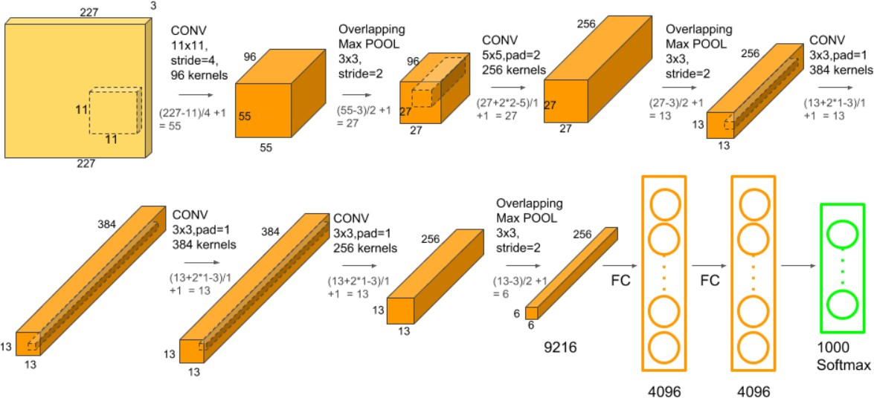

Fig 1. ALEXNET Architecture

INCEPTION NETWORK
The previous networks perform convolutions layer-by-layer, and the results are input to the next layer. However, inception defines a module that carries out different convolution operations, and finally splices different convolution operations as output. Experimental results show that it has a good performance. The Inception network is different from the general convolution neural network in that it contains multiple convolution kernels of different sizes in its convolution layer, and the output of Inception is the depth stitching of the feature map.

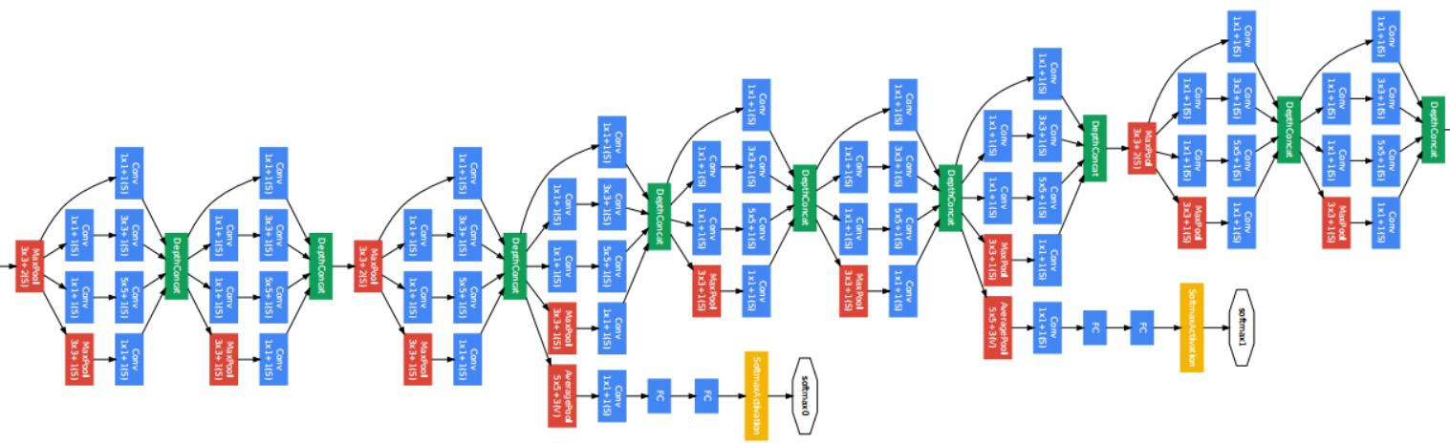
Fig 2. Inception Net V1 Architecture

RESIDUAL NETWORK

The residual network has not only made great progress in depth but the architecture is also different from the previous networks. It inserts shortcut connections, which turn the network into its counterpart residual version. The identity shortcuts can be directly used when the input and output are of the same dimensions. The depth of representations is of central importance for many visual recognition tasks. Solely due to extremely deep representations, it obtained a 28% relative improvement on the COCO object detection dataset. Deep residual nets won 1st place on the ImageNet detection tasks, ImageNet localization, COCO detection, and COCO segmentation.

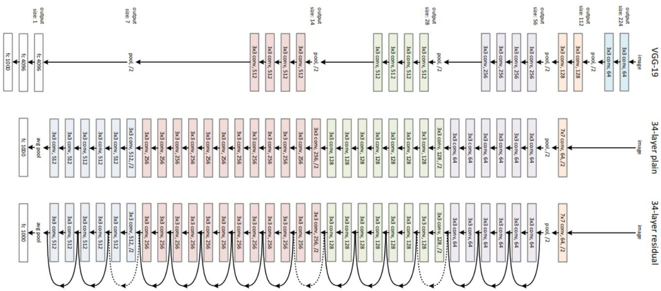

Fig 3. ResNet Architecture

DENSE NETWORK

The dense convolutional network (DenseNet) connects each layer to every other layer in a feedforward fashion. Whereas traditional convolutional networks with L layers have L connections-one between each layer and its subsequent layer-our network has L(L+1)/2 direct connections. For each layer, the feature-maps of all preceding layers are used as inputs, and its feature-maps are used as inputs into all subsequent layers. DenseNets have several compelling advantages: they alleviate the vanishing-gradient problem, strengthen feature propagation, encourage feature reuse, and substantially reduce the number of parameters. It was evaluated on four highly competitive object recognition benchmark tasks (CIFAR-10, CIFAR-100, SVHN, and ImageNet). DenseNets obtain significant improvements over the state-of-the-art on most of them, whilst requiring less computation to achieve high performance.

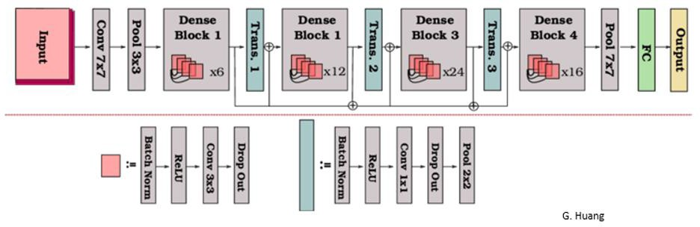

Fig 4. DenseNet Architecture

3.1 DRAWBACKS OF EXISTING SYSTEM

  - The above-mentioned models fail to address key problems related to image super resolution and image denoising.
  - The depth of AlexNet model is very less and hence it struggles to learn features from image sets. We can observe that it takes more time to achieve higher accuracy results compared to other models.
  - Inception Network have sometimes use convolutions such as 5*5 that causes the input dimensions to decrease by a large margin. This causes the neural network to uses some accuracy decrease.
  - Resnets include adding skip level connections for which you have taken into account the dimensionality between the different layers which can become a headache.

3.2 PROPOSED SYSTEM

- We propose Restructured Residual Dense Network (RRDN) to solve the problem of crop leaf disease identification. As the original model was used in image super resolution, the input images have no dimension reduction operation, which may work well in a single block.
- But in the image classification task, tens of thousands of images are input, which will require considerably more computing resources, as well as low efficiency.
- So, the input image is convolved first in Res-Dense-Block (RDB)and the tensor is batch normalized after the convolution in the RDB block.
- In this experiment, the input size of the tensor is 196∗196∗64, then input the 3-layer RDB for feature extraction. Then the output size is 98∗98∗64, which can be used for residual added.
- After that, the block output by the 3-layer RDB and the initial input tensor create the residual connection operation and output a new tensor.

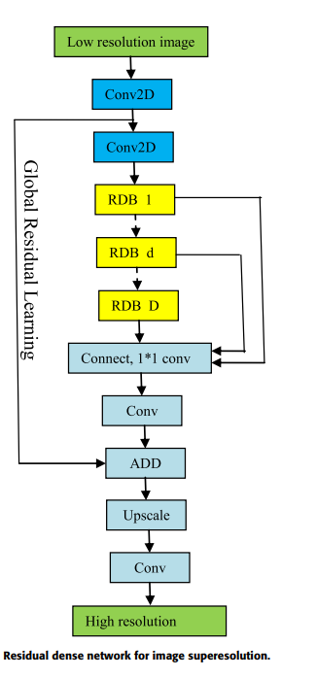

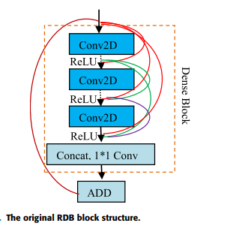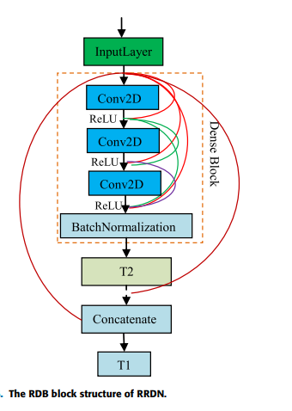

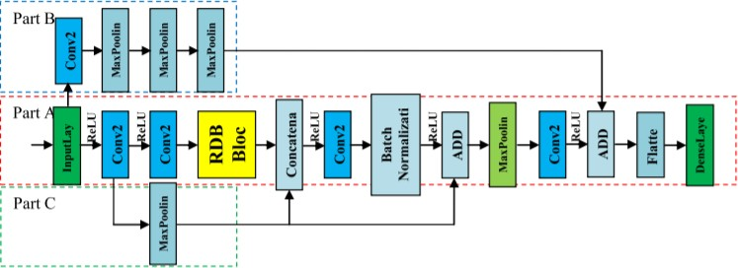

Architecture and workflow of RRDN

3.3 HARDWARE AND SOFTWARE REQUIREMENTS

3.3.1 HARWARE REQUIREMENTS
- PROCESSOR: INTEL CORE i5
- RAM: 8GB DD RAM
- GPU: Nvidia Geforce GTX 1080Ti
- HARD DISK: 250 GB

3.3.2 SOFTWARE REQUIREMENTS
- OPERATING SYSTEM: Windows 10
- FRAMEWORK: Tensorflow 2.3.1, Cuda 10.1
- PROGRAMMING LANGUAGE: Python, HTML
- FRONT END: Jupyter Notebook

CHAPTER 4
METHODOLOGIES

There are various modules involved in process of classify tomato leaf disease leaves. The modules are listed below:
- Dataset
- Pre-processing
- Data Partition
- Constructing RRDN
- Defining Activation and Loss Functions
- Evaluation

4.1 DATASET
- The tomato leaf diseases dataset in AI CHALLENGER is used for this experiment, which includes 13,185 images within 9 classes.
- The images are the same size of 196∗196 pixels.
- The class details are shown in table below.

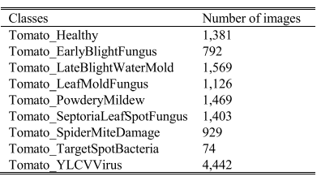

Part of the tomato leaf disease images is shown in the figure below.

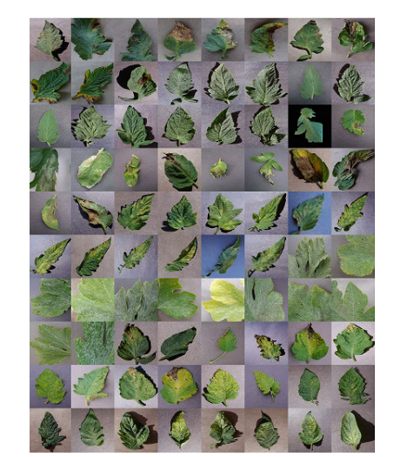

4.2 PRE-PROCESSING

The input images are represented in the form of pixel values that range from (0-255).

Image pre-processing needs to be done to transform the pixel values into a standard scale (i.e., 0-1).

This results in faster convergence and training time will be reduced.

Here, we are using Standardization technique to transform the pixel values into a standard scale.

4.3 DATA PARTITION

The dataset is divided into 3 parts, such that

60% is used for training.

20% is used as the validation set.

20% is used for the test set.

4.4 CONSTRUCTING RRDN

The input image is convolved first in Res-Dense-Block (RDB) and the tensor is batch normalized after the convolution in the RDB block. Where T2 is activated by the LeakyReLU function, and T1 is the residual concatenate tensor by T2 and the input layers.

T = N(C(I)) …………………………………………. (1)

In Formula (1), the operator N denotes the normalization operation, and the operator C denotes the convolution operation, and I denotes the input layer. T is the tensor that has been normalized in RDB.

In the original RDB block, T1 as the output tensor by RDB, this block is used to transitive tensor to next RDB block, which can be used in the whole model life cycle, this method is useful in image SR. However, in the classification task it takes a very large weight, which affects the classification efficiency and accuracy.

To solve this problem, we have abandoned the tensor T2 that has no residual concatenation in RDB and finally use it for residual concatenation.

T 1 = Concate(T , I)

T 2 = L(T)) ………………………………………… (2)

In Formula (2), Concate denotes the residual concatenate operation. T 1 is the tensor that has been concatenated between T and I, where L denotes the LeakyReLU operation, T 2 is the tensor after LeakyReLU with an alpha of 0.3.

In this experiment, the input size of the tensor is 196∗196∗64, then input the 3-layer RDB for feature extraction. Then the output size is 98∗98∗64, which can be used for residual added. After that, the block output by the 3-layer RDB and the initial input tensor create the residual connection operation and output a new tensor(T3).

T 3 = R 3 (C(C(I))) ………………………………...(3)

In Formula (3), Operator R 3 denotes the 3-layer RDB operation. To improve the classification accuracy, the input layer can be reloaded for residual connection, after 3 pooling operations; the output image size is 1∗1 ∗128. Then, the residual connected operation is performed with tensor T3, tensor T4 is output, which prepares for classification, as shown in Formula (4).

T 4 = Concate(T 3, P 3 (C(I))) ……………………..(4)

We add a dense layer for classification. To prevent overfitting, an L2_regularizer is added in the dense layer, the adadelta function is used for the optimizer, and the loss function is cross-entropy.

4.5 DEFINING LOSS AND ACTIVATION FUNCTIONS

RDB ACTIVATION FUNCTION

In the RDB block, the ReLU activation function is used after the convolution operation in every layer.

The LeakyReLU function is used in the tensor after normalization to solve the dead neuron phenomenon.

LOSS FUNCTION

The loss function is one of the important tools to measure the gap between network output and targets.

To deal with the multiclassification problem more conveniently, the cross-entropy loss function was used in the loss layer and the softmax activation function in the output layer.

OPTIMIZER FUNCTION

In the optimization layer, the adadelta optimizer was used to minimize the loss function and adjust the learning rate adaptively with the initial learning rate of 0.0001.

BATCH SIZE AND EPOCHS

We set the value of the batch size to 8, 16 or 32. When the batch size is 16 or 32, there was a gradient fluctuation phenomenon, so we set the value to 8 as the batch size to feed into the model.

In addition, when the epochs were more than 200, the loss convergence was no longer obvious, so we trained the model for 200 epochs.

CHAPTER 5

FUTURE ENHANCEMENTS

This project proposes a residual dense network-based tomato leaf disease identification model; this inspiration comes from RDN in the image super resolution task. By adjusting the model architecture, we transformed it into a classification model, which obtained a higher accuracy than state-of-the-art models. Because this model is suitable for the tomato dataset, we will attempt to perform transfer learning from the tomato dataset to other plants through the model adjustment to improve the generalization ability. In the future, we hope to apply this work in practical work to make a small contribution to developing agricultural intelligence.

CHAPTER 6

CONCLUSION

Tomato is a very popular food worldwide for food or for seasoning; it is one of the necessities of life. Even for entertainment. The ‘‘Tomatina’’ held each year on the last Wednesday in August originated in Spain where tens of thousands of revelers from around the world pelt each other with tons of tomatoes. To produce better quality tomatoes, people must overcome the problem of plant diseases. Generally, plant diseases appear on the leaves first, which makes the leaf disease identification particularly important.

